NOMINATIONS FORM

How to complete this form
The nominee completes Part A and passes this to National headquarters for their endorsement. The NHQ then completes Part B to confirm that they approve the nomination.

If you have any questions about completing this form please contact Ms. Darshana Pawaskar. Joint Director Guides jdg@bsgindia.org

Submitting your nomination
The following should be returned to the World Bureau by the nominee:
- Part A of the form
- Part B of the form
- A recent photograph of herself (portrait photo in either JPEG or TIF format) or a printed photo (passport format),

This should be sent by email or post to the following:

Email: jdg@bsgindia.org and info@bsgindia.org

Post: Confidential – World Board Nominations

Members applying for the nominations send their forms on or before 23.59 (UTC) on Wednesday 10th March 2021. Forms received after this deadline will not be considered.

Privacy notice
Please note that the personal information provided as part of this nomination form will be used only for the purposes of processing the nomination and will be handled by WAGGGS in accordance with UK data protection regulations.

Information will be stored by WAGGGS in both manual and electronic forms. This information will only be accessible to, and shared with, members of WAGGGS staff, members of the Nominations Committee and members of the World Board.

For unsuccessful candidates, information will be kept for a maximum period of one year after the closing date for nominations, after which it will be destroyed.

PART A: To be completed by the nominee

PERSONAL INFORMATION
Given names (in full)
Preferred name
Family name
Member Organisation
Contact details | Main email address
 | Alternative email address
 | Main telephone number
 | Telephone number (WhatsApp)
 | Skype
Date of birth

PERSONAL STATEMENT
Please indicate, in three hundred (300) words or less, why you would like to become a member of the World Board, and how you feel you can contribute to the work of WAGGGS.

SKILLS AND EXPERIENCE
Reflecting on the ESSENTIAL skills and experience required for World Board as described in the Nominations Pack please describe, in four hundred (400) words or less, your skills and experience within and/or outside the Girl Guiding/Girl Scouting movement, giving specific examples wherever possible.

Reflecting on the DESIRABLE skills and experience for World Board as described in the Nominations Pack please describe, in four hundred (400) words or less, your skills and experience within and/or outside the Girl Guiding/Girl Scouting movement, giving specific examples wherever possible.
LEADERSHIP MODEL SELF-REFLECTION MINDSETS
Using the template below reflect on how comfortable you feel consciously and regularly practising each of the WAGGGS leadership mindsets in your every-day life. Please make a dot on the line for each mindset, with the centre = not comfortable at all and the outer ring = very comfortable, then join the dots up to make a ring. This is a personal reflection and your results will not be shared beyond the Nominations Committee.

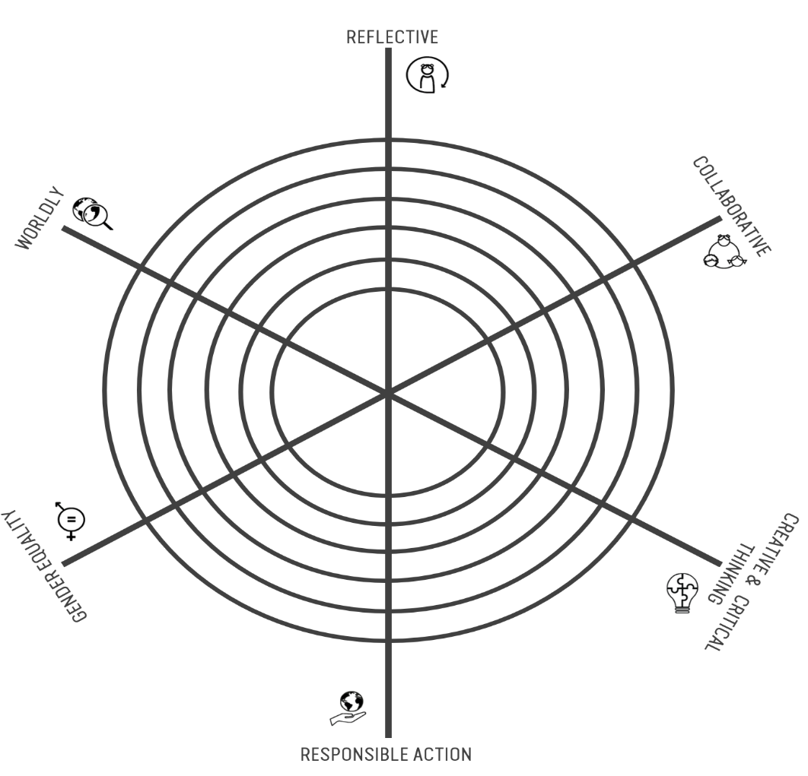
Reflecting on this exercise, please share:
- Which mindset do you feel you already practise the most? Can you give an example?

- Which mindset do you most want to practise more in your every-day life, and why?

- Which mindset do you feel you most need to develop further to support you in a role on the World Board, and why?

Being able to recognise when and how you have practised leadership is a key to being more conscious about who you are as a leader. We can practise leadership in small, every-day ways too, not just in Girl Guiding and Girl Scouting but in all parts of our lives.

For each of the following ten leadership outcomes, tell us about a time when you feel you achieved the outcome. Try to give different specific examples for each outcome. (maximum of 100 words per outcome):

Leaders of the Movement | Your example…
Treat herself kindly
Work with others to create spaces where everyone can fully participate
Challenge herself to understand and take into account different perspectives
Adapt her behaviour to the context
Challenge gender expectations
Seek the information she needs to understand the full picture
Innovate to create positive impact
Learn from her own feelings and experiences
Empower any and every girl to practise leadership
Make choices rooted in her values

VOLUNTARY POSITIONS AND PROFESSIONAL APPOINTMENTS
Please give details below of any past (not more than ten years ago) and current positions that you have held within a Member Organisation, WAGGGS, and professional, NGO or business appointments.

 | Current positions held  (please give the year started) | Previous positions held  (please give the year started and ended)
Member Organisation
World Association of Girl Guides and Girl Scouts (WAGGGS)
Other voluntary positions
Professional/NGO/
business appointments

PARTICIPATION IN EVENTS
Please give details, including the year where possible, of any relevant events that you have participated in within the last six years.

World Association of Girl Guides and Girl Scouts (WAGGGS) events
Other relevant national, regional or global events
LANGUAGE SKILLS
The ability to use English as a working language is a requirement for World Board members. This is because an important part of the Board’s role involves governance and ensuring compliance with English Charity Law, and other relevant legislation or regulations.

What is your mother tongue?

Please indicate your skill in the following languages using the following key:
1: fluent; 2: intermediate; 3: basic

 | English | Arabic | French | Spanish | Other (please state language)
Skill level

INFORMATION TECHNOLOGY
Board members communicate regularly by email, WhatsApp and conference call throughout the year.

Do you currently have regular and reliable access to the internet? | Yes / No
Would you be able to respond promptly (e.g. within 48 hours) to electronic communication? | Yes / No

REFEREES
Please provide details of two referees that the Nominations Committee can contact:

 |  | Referee  (professional context) | Referee  (Guiding/Girl Scouting context)
Name of referee
Professional/Member Organisation (if applicable)
Role/Position held
How do they know the nominee?
Contact details | Postal address
 | Main email address
 | Alternative email address
 | Main telephone number
 | Telephone number (Whatsapp)
 | Skype

NOMINEE’S DECLARATION
By submitting this nomination form, I hereby confirm that (please tick all boxes):

I accept the nomination to the World Board
I agree to participate in a telephone interview with members of the Nominations Committee.
To my knowledge the information given on this nominations form is correct and complete.
I understand that I am personally responsible for informing WAGGGS if my contact details change after submitting this nominations form.
I understand that I have a responsibility to actively participate in the nominations process, and respond to requests for information and all communications from the Nominations Committee in a timely manner. I understand that failure to comply with these requirements will result in an official warning being issued and may ultimately result in the Nominations Committee withdrawing my nomination.
I agree that references will be sought to support my application.
I accept the principles of WAGGGS as shown in the Constitution and its values.
I give permission, in accordance with data protection regulations, for WAGGGS to process the details in this form for the purposes of my nomination. This information can be stored in both manual and electronic form.
I consent to my photograph being included in the World Board Election Booklet and understand that this will be available publicly online. Additionally I agree to my name and photograph being used in social media posts.

Signed (electronic signature/scan is acceptable)
Date

PART B
To be completed by the nominating Member Organisation (NHQ)

By signing below, I confirm, on behalf of my Member Organisation, that I have read the Nominations Pack in full and Part A of this form and I believe this volunteer fits the profile described, and has the capabilities required to serve on the World Board. I understand that the nominee has a responsibility to actively participate in the nominations process, and respond to requests for information and all communications from the Nominations Committee in a timely manner and that failure to comply with these requirements will result in an official warning being issued to her and may ultimately result in the Nominations Committee withdrawing her nomination. I understand that my organisation will be informed by WAGGGS if an official warning is issued and before any further action is taken.

Name of Proposer
Proposer’s Member Organisation
Position held in Member Organisation
Proposer’s contact details | Main email address
 | Alternative email address
 | Main telephone number
 | Telephone number (WhatsApp)
 | Skype
Signed (electronic signature/scan is acceptable)
Date

